Solving Real-World Systems Word Problems HW
- Solve by substitution:
4y – x = 9
3y + 2x = 4
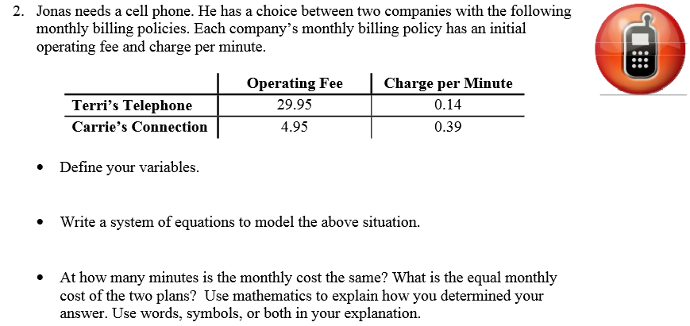
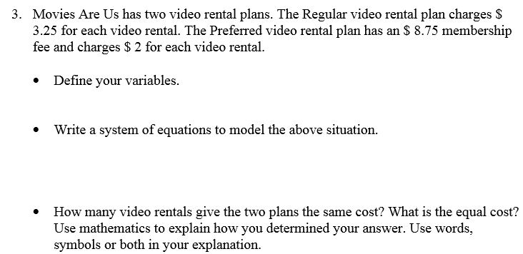
4) Solve for a. 24a – 22 = -4(1 – 6a)

5) Solve for x. -5(1 – 5x) + 5(-8x – 2) = -4x – 8x

